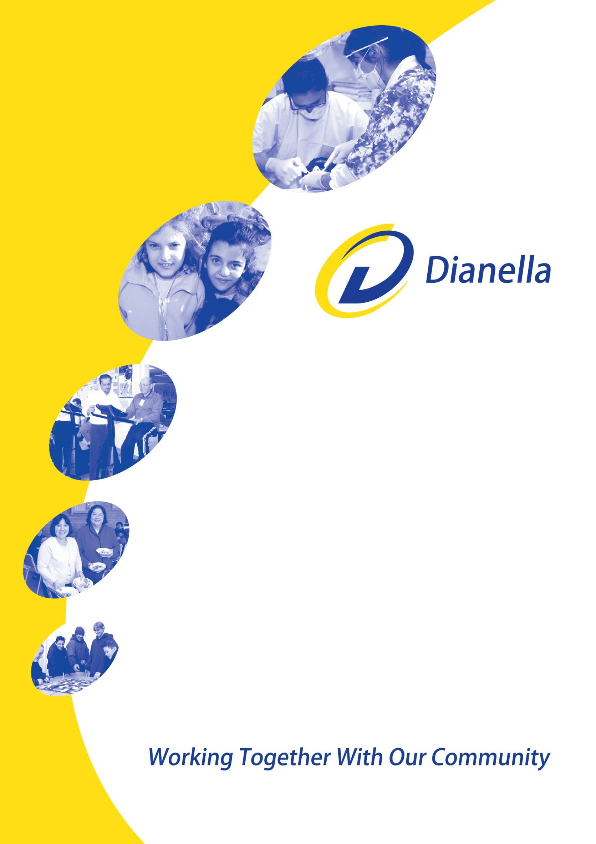

Position title: | General Manager Child, Youth and Family Services
Location: | Craigieburn (and at other Dianella sites) The work location may also vary depending on space availability and service need
Job Status: | Three Year Contract
Reports to: | Chief Executive Officer
Date: | August 2013

Position Description

Background
Dianella Community Health is a Community Health provider of clinical and social health services in the City of Hume in North West Melbourne. It is a registered charity, independent of Government, a company Limited by Guarantee, owned and operated by the membership under the Health Services Act (1988). The organisation delivers primary health services to a wide variety of children and adults from different ethnic groups and socio-economic circumstances in our rapidly growing community.

The organisation operates across six sites including Craigieburn, Meadow Heights and Broadmeadows. Dianella is currently supported by 220 full and part time staff and approximately 100 volunteers. The organisation has an annual budget of approximately $17m.

The community served is one of the fastest growing in Melbourne and represents a rich diversity in culture and background. It is also one of the most disadvantaged communities in Victoria and is characterised by the following increasing demands on services:
- Ageing population growing in Broadmeadows SLA, with the current 60+ population growing by 42.7% by 2031.
- Population increases in the Craigieburn SLA, with current population projected to grow by 122% by 2031.
- Broadmeadows, Dallas, Coolaroo, Campbellfield, Meadow Heights and Jacana all fall within the first decile of most disadvantaged suburbs in metropolitan Melbourne.
Dianella has strong links with the City of Hume, the Department of Health (DoH), local non-government organisations, the Northern Hospital, and a wide variety of community groups.

Having secured funding for the construction of a $10M “Super Clinic” (expected to be completed in 2014), it is anticipated Dianella will relocate some sites to the purpose built facility in the heart of Broadmeadows in conjunction with other key service providers.

In November 2010, the Commonwealth Government invited tenders for capital funding to construct and operate a Super Clinic in Hume. The Hume Super Clinic proposed by Dianella will realise the objectives of the national Super Clinics Program through the establishment of a Super Clinic in the Broadmeadows Central Activity District (CAD). It aims to improve access to services in an area that has been historically deficient in services and has experienced rapid growth in its population. The Super Clinic will provide a best practice integrated multidisciplinary service model including urgent care. Operational funds will be accessed through a variety of existing and new private and public funding sources.

Core Business
Dianella’s core business is the delivery of primary health care services and preventative health initiatives. Services include:-
- Aged Care Support
- Asthma Education
- Audiology
- Community Development
- Community Health Nursing
- Children’s Continence Program
- Dental
- Dietetics
- Early Childhood Development
- Health Promotion
- Medical
- Mental Health
- Occupational Therapy (Child and Adult)
- Paediatrics
- Physiotherapy
- Podiatry
- Psychology (Child and Adult)
- Social Work
- Speech Pathology
- Volunteer led exercise programs
- Youth Counselling

Guiding Principles
Equitable Access to Services
We believe that accessibility to services embraces cultural, economic and social aspects. We are committed to ensuring that all people in our service area can access our services regardless of where they live, their linguistic and cultural background or their economic and social circumstances. Our services are offered both at home and/or on site.

Advocacy
Dianella advocates on behalf of those groups and individuals within the community who are disadvantaged, discriminated against or marginalised with respect to access to services and resources necessary for their well being.

Responsiveness to Community Diversity
Dianella recognises that it serves an extremely diverse community and is dedicated to ensuring that responsive programs and services are provided to meet the needs of Indigenous and culturally and linguistically diverse communities.

Health Promotion/Preventative Approach
Dianella espouses the principles identified in the Ottawa Charter for Health Promotion (1986) and the Jakarta Declaration (1997) as the basis of prevention and health promotion activities. Within these principles Dianella will address the socio/political, environmental, emotional and physical determinants of health.

Best Practice within Community Health
Dianella is committed to “Best Practice” and will ensure that all aspects of service provision, education, training and research activities reflect this principle.

Accountability
Dianella operates with transparency and openness and is fully committed to ensuring that accountability to the community and clients is of utmost priority.

General Manager Child, Youth and Family Services – Principal Accountability
The General Manager Child, Youth and Family Services holds a key position in the organisation and is accountable for programs and teams in the directorate which include:
- Mental Health and Wellbeing Team
- Early Childhood Development Team
- Other projects as directed
The position is responsible for and required to meet a range of key performance indicators established for the directorate including quality, budget, and agreed Service Agreement targets. The service requires a strong leader with excellent skills in leadership, communication and strategic partnerships.

The General Manager Child, Youth and Family Services reports directly to the Chief Executive Officer.

Skills and Expertise
- Minimum of 10 years experience in the health sector;
- High level management and leadership expertise;
- Experience in a senior management role with government, health or child and family services
- Excellent communicator and negotiator with the capacity to develop and implement key strategic projects and plans;
- Sensitivity to issues related to the provision of services in a community of high cultural diversity
- Ability to effectively delegate appropriate responsibilities to Branch Managers;
- Self-reliance and ability to work independently and innovatively within the policies and protocols of the agency;
- Significant proven financial management and business planning skills;
- Strong communication skills that build effective internal and external relationships;
- Sound appreciation of, and commitment to, good corporate governance;
- Working knowledge of the private and public health care sector and or the Not for Profit sector

The Role
Overall the role is required to meet a range of outcomes and deliverables against the Dianella Strategic Plan and the Directorates Business Plan. In addition to these key deliverables the following areas are also required of the role:

Strategic Leadership
- Provide the CEO and the Board with strategic and authoritative advice on matters as they relate to the Child, Youth and Family Services directorate;
- Form strategic alliances with key stakeholders, particularly providers of services;
- Provide leadership in strategic development and planning;
- Partner and engage with external services networks and local agencies;
- Maintain an understanding of and contribution to broader health issues and policy development at a Local, State and National level;
- Act as mentor and coach to staff, assisting them to achieve organisational goals

Service Delivery and Program Development
- Ensure Branch Managers and team leaders are supported and empowered to develop areas of expertise in their staff and manage services in a way which promotes the health and wellbeing of residents of the City of Hume;
- Manage budget and negotiate budgetary issues with relevant managers;
- Identify opportunities for other funding sources including the preparation of tenders;
- Ensure that all contractual requirements are met including budget parameters, service
targets and quality expectations;
- Work with the CEO and the management team to develop costing for tenders and submissions;
- In consultation with the Directorate ensure all regular reports are prepared and submitted in timely manner, particularly the financial management reports.

Quality
- Ensure that all relevant external standards are achieved;
- Ensure that Dianella policies and procedures are based on the best available evidence;
- Lead the development, implementation, monitoring and evaluation of programs ensuring
that they are evidence-based and meet clients’ needs;
- Lead the review and development of work practices that deliver efficient and high quality services in line with best practice;
- Ensure that strategies are in place to continuously improve the quality of services.

Information Management
- Ensure that effective systems for records management are in place and comply with relevant Privacy Legislation;
- Ensure that external reporting, as required by funding bodies, is completed in an accurate and timely manner;
- Ensure that reporting systems have the capability to generate data to assist with planning of new services and evaluate current services.

Human Resource Management
- Advise the CEO on implementation of recruitment, induction and retention systems that attract and maintain high quality professional staff and meet all legislative requirements;
- Assist the CEO in developing and maintaining a cohesive management team;
- Assist and seek advice for the CEO on industrial relations negotiations;
- Ensure that staff are paid in line with appropriate industrial awards or contracts and that all entitlements are honoured;
- Ensure that the directorate recruits and retains the best people
- Ensure that practices are in line with current OH&S legislation and standards.

Financial Management
- Ensure that finances of the Service are managed in accordance with statutory requirements, industry standards and maximise the services resources;
- Develop and establish financial strategies and financial risk mitigation practices that would ensure all programs are effectively resourced to achieve or exceed financial targets;
- Identify opportunities to enhance the financial sustainability of the Service;
- Ensure that all financial transactions are undertaken in line with approved Dianella policy and delegations;
- Provide timely, accurate reports to the Board, staff and funding bodies to meet all reporting and accountability requirements including the annual report and enable the monitoring of budgets.

Dianella Board of Directors & CEO
- Provide reports to the Board and CEO as required in a timely manner;
- Provide written reports to the Board and CEO on current issues, new initiatives and other relevant topics as required;
- Keep the Board & CEO up to date regarding government and industry policy;
- Report on an annual framework of key performance indicators for the Service and report against those KPIs on a monthly basis.

Working Relationships

Internal
- CEO
- Members of the Executive Management Team
- Key Corporate staff
- Managers and Team leaders

Board of Directors, when appropriate

External
- Community
- Funding bodies
- Consortia Partners
- Key Stakeholders

Behavioural Competencies to be displayed include:

Teamwork
- Create a cohesive high functioning senior management group;
- Communicate with all staff and work with them to meet organisational objectives consistent with the values of the organisation;
- Encourage staff self-improvement by identifying appropriate training and support;
- Promote positive organisational workforce culture to promote high organisational performance.

Leadership
- Lead, manage and develop people;
- Demonstrate commitment and expertise to promote the organisation’s values and a sound organisational culture of client service, performance, accountability and integrity;
- Act as a mentor and influence the development of others;
- Ensure that General Managers and in turn all employees are supported and empowered to develop areas of expertise in their staff and manage services in a way which promotes the health and wellbeing of the residents of the City of Hume and surrounds.

Business Expertise
- Exercise high level financial and commercial competence;
- Put in place continuous professional and quality development;
- Identify and understand sensitive issues affecting the industry;
- Exercise good understanding of the health environment, strategic planning, policy development and organisational development.

Communication
- Lead, coach and develop the staff to present sound financial and business solutions;
- Adopt a dynamic management style that fosters participation and personal growth;
- Negotiate and influence others to appreciate a point of view;
- Lead with exceptional interpersonal and communication skills;
- Produce well structured concise business reports and correspondence.

Other Duties
- As directed from time to time by the Chief Executive Officer

Delegation of Authority
As per organisational Delegations Policy and Procedures.

Qualifications and Experience
- Tertiary qualifications in health, business or a related discipline
- Postgraduate qualifications in a related discipline or significant comparable commercial experience
- A minimum of five years experience in a senior management position, preferably in the Health / Not for Profit Sector
- Active engagement in key professional associations and/or appropriate professional bodies that pertain to the Directorate

Salary and Conditions
- A three year contract will be negotiated with the successful applicant. This will include a fully maintained company vehicle.
- Appointment to this position is subject to passing a National Police Check and Working with Children’s Check
- Participate in the annual staff review process
- Probationary period of six months

